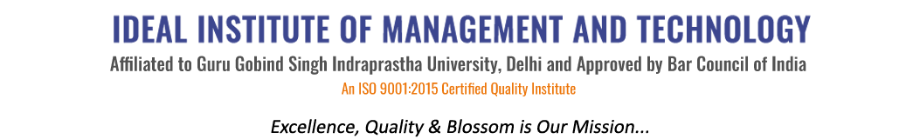
16 X, Karkardooma Institutional Area, (Near Telephone Exchange)
Delhi-110092
+91 (11) 22372639, 22375961,
http://idealinstitute.edu.in
Mother Dairy (20-10-15)
BBA (Gen) 1st Shift

S.No | STUDENT NAME | ROLL NO
1 | Akansha Gupta | 00113401715
2 | Abhishek Gupta | 00213401715
3 | Aditya Bhandari | 00313401715
4 | Akannsha Negi | 00413401715
5 | Aman Jindal | 00513401715
6 | Anirudh Mukharjee | 00713401715
7 | Anushka Vardiya | 00813401715
8 | Bharti Malhotra | 00913401715
9 | Gagandeep Singh Taneja | 01013401715
10 | Garvita Kumar | 01113401715
11 | Gulafshan Shabnam | 01213401715
12 | Ishan Sharma | 01313401715
13 | Kartikeya Dua | 01413401715
14 | Manisha Tyagi | 01513401715
15 | Mayank Sethi | 01613401715
16 | Mohd. Jaman | 01713401715
17 | Muskan Goyal | 01813401715
18 | Nancy Kumari | 01913401715
19 | Nikita Sharma | 02013401715
20 | Nishant | 02113401715
21 | Niyati Sharma | 02213401715
22 | Parul Sajwan | 02313401715
23 | Pranav Singh | 02413401715
24 | Rashi Jain | 02613401715
25 | Sakshi Jain | 02713401715
26 | Sanil Chawla | 02813401715
27 | Shefali Rawat | 02913401715
28 | Shivam Lamba | 03013401715
29 | Subham Kumar Kaushal | 03113401715
30 | Shuruti Gupta | 03213401715
31 | Srishti Goel | 03313401715

